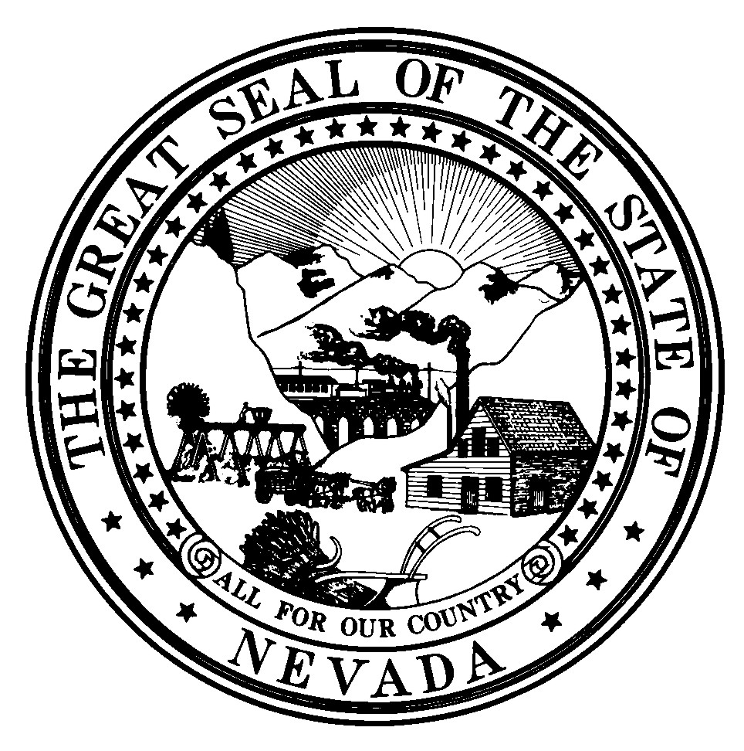
Maggie Tracey, O.M.D., President
Abraham Jim Nagy, M.D. Vice President
Lisa Grant, O.M.D., Secretary/Treasurer
Michael Ferris, Member
Chia Hua Linda Chow, Member
Michael Smith, Member
Jennifer Braster, Member
Merle Lok, Executive Director

Brian Sandoval, Governor

STATE OF NEVADA

BOARD OF ORIENTAL MEDICINE

***PUBLIC NOTICE***
REGULAR BOARD MEETING AND HEARING FOR THE ADOPTION OF A PERMANENT REGULATION OF THE NEVADA STATE BOARD OF ORIENTAL MEDICINE

October 23, 2018 @ 12:00 PM

AT THE FOLLOWING LOCATION:

Grant Sawyer Building, Office of the Attorney General, 555 East Washington Ave., Room #4500, Las Vegas, NV 89101 and Office of the Attorney General, 5420 Kietzke Lane, Suite 202, Reno, NV 89511.
***MINUTES***

- CALL TO ORDER (Discussion/For Possible Action) Maggie Tracey, OMD, President
Roll call to determine presence of a quorum, at 12:00 pm
Board Members Present:
Dr. Maggie Tracey, OMD (Reno location)
Dr. Michael Ferris, OMD (Via Telephone)
Jennifer Braster (Via Telephone)
Dr. Lisa Grant (Las Vegas location)
Michael Smith (Las Vegas location)

Board Staff:
Merle Lok, Executive Director
Asheesh Bhalla, Deputy AG

Public:
Susan Fisher (Reno location)
Daniel Davies (Via Telephone)
Dr. Rachel Kohl (Via Telephone)
Dr. Anita Lanier (Las Vegas location)
Dr. DuWayne Steele (Las Vegas location)

- Public Comment (Discussion Only).
None

- Adoption of agenda (For Possible Action)
Motion: Dr. Grant motioned to approve
Second: Ms. Braster
Action: Motion carried unanimously

4. PUBLIC HEARING: Discussion/Consideration/Potential Action regarding the proposed Regulations including:
-Revision to NAC 634A regarding addition of definitions of national organizations
-Revision to NAC 634A.060 regarding a salary for the position of Secretary-Treasurer
-Revision to NAC 634A.071 regarding application submission deadlines
-Revision to NAC 634A.080 regarding approval of programs of study for Oriental medicine and applications for licensure by endorsement and applicant qualifications
-Revision to 634A.085 regarding national examination certification requirements
-Revision to 634A regarding approval of curriculum of schools and colleges of Oriental medicine in Nevada
-Revision to 634.095A regarding proficiency of applicant in English language
-Revision to 634A.100 regarding the practical examination
-Revision to 634A.110 regarding reexamination of applicants who fail the practical exam
-Revision to 634A.135 regarding continuing education and maintenance of inactive licenses
-Revision to 634A.137 regarding approval of continuing education courses
-Revision to 634A.140 regarding payment of annual registration fees for new licensees
-Revision to 634A. 150 regarding reinstatement of cancelled licenses
-Revision to 634A.165 regarding Board fees
-Revision to 634A.170 regarding grounds for disciplinary action
(For Possible Action).

Motion: Dr. Grant motioned to approve for adoption
Second: Ms. Braster
Action: Motion carried unanimously

- Approve or disapprove the previous board meeting minutes of June 25, 2018 and July 9, 2018 (For Possible Action).
Motion: Dr. Grant motioned to approve
Second: Dr. Ferris
Action: Motion carried unanimously

- Approve or disapprove of possible changes to NRS 634A (For Possible Action).
Dr. Tracey stated that the scope of the changes should include dry needling and the licensing exam. Dr. Grant discussed a few possible changes including bringing the definitions of acupuncture, herbs, and oriental medicine more in line with the modern definitions. Dr. Grant also discussed adding a statute that states a new OM school may be established only if it enters into pre-accreditation status with ACAOM as soon as legally possible and continues to maintain ACAOM accreditation during its operation. Dr. Grant stated that the biggest change may be the exam wherein all the categories will be eliminated except for the section testing the laws and regulations of Nevada as future applicants will have and maintain the Oriental Medicine Certification by NCCAOM. Dr. Grant also stated that another statute change would affect all OM doctors who practice injection therapy; they must apply for an endorsement from the Board and show that they have at least 24 hours of NCCAOM approved training for injection therapy. Dr. Tracey and Dr. Grant stated that if the licensees have changes, they can submit to the ED by 10/31/2018. Dr. Tracey stated that the item will be tabled and brought up at the next meeting.

- Discussion by Susan Fisher regarding lobbying updates (For Discussion Only)
Ms. Fisher stated that there are no updates but she discussed the timetable for the new legislators coming in and the legislative process. Ms. Fisher also talked about potential timeframes for submitting the proposed legislation which is to be by December and February.

- Approve or disapprove of the CEU title Oriental Medical Conference 2018/East Meet West sponsored by the Nevada Society of Oriental Medicine on 9/8/2018 for 10 credit hours in Las Vegas, Nevada (For Possible Action).
Motion: Dr. Grant motioned to approve
Second: Mr. Smith
Action: Motion carried unanimously

- Approve or disapprove of the CEU titled Chi Nei Tsang: Medical Abdominal Massage sponsored by the Nevada Coalition for Acupuncture on 10/7/2018 for 8 credit hours in Las Vegas, Nevada (For Possible Action).
Motion: Dr. Grant motioned to approve
Second: Mr. Smith
Action: The present Board members vote Aye, except for Dr. Ferris who recused himself

- Approve or disapprove of the CEU titled Reversing Autoimmune Disease with Acupuncture and Functional Medicine, Part 1 and 2, for 16 hours sponsored by Lotus Institute of Integrative Medicine online (For Possible Action).
Motion: Dr. Grant motioned to approve
Second: Mr. Smith
Action: Motion carried unanimously

- Approve or disapprove of the CEU titled Advanced Cupping Techniques for 16 hours sponsored by International Cupping Therapy Association in Los Angeles, CA on 9/17-9/18/2018 (For Possible Action).
Motion: Mr. Smith motioned to approve
Second: Dr. Grant
Action: Motion carried unanimously

- Approve or disapprove of the licensure exam to be held on December 15, 2018 from 1 pm to 5 pm to be administered by Dr. Sandip Thanki at 4350 E. Sunset Road, Ste 107A, Henderson, NV 89014 at the rate of $30 per hour (For Possible Action).
Motion: Dr. Grant motioned to approve
Second: Mr. Smith
Action: Motion carried unanimously

- Approve or disapprove of hiring an exam writer (For Possible Action).
Dr. Tracey stated that she has been in contact with 3 possible exam writers and is looking to hire at the same rate as before.
Motion: Mr. Smith motioned to approve
Second: Dr. Grant
Action: Motion carried unanimously

- Approve or disapprove of the applicants to take the December 15, 2018 state licensing exam:
- Jessica Mlakar
- Noriko Ueda Lang
C. Grace Im
D. Choonkook Han
(For Possible Action)
Dr. Ferris stated that he has taught some of the applicants. ED stated that the applicants have met the criteria.
Motion: Dr. Grant motioned to approve
Second: Mr. Smith
Action: Motion carried unanimously

- Approve or disapprove of Yvette Guzman re-taking the licensing exam on December 15, 2018 (For Possible Action).
Motion: Dr. Grant motioned to approve
Second: Mr. Smith
Action: Motion carried unanimously

- Approve or disapprove of whether teaching hours at an Oriental Medical school will satisfy the licensing didactic hours requirement (For Possible Action)
Dr. Tracey stated an applicant has to be a student of the subject and not a teacher to satisfy the licensing didactic hours. Dr. Tracey also stated that the law is clear that it has to be didactic hours. Dr. Grant agreed with Dr. Tracey. Dr. Grant stated the didactic hours in a school show that the applicant has been taught in an approved manner. Dr. Ferris asked whether an applicant who has the qualifications should be able to make up the missing hours by teaching. The DAG stated that as a matter of interpretation, there is no basis for the Board to go down the path to allow teaching didactic hours to take the place of learning by didactic hours.
Motion: Dr. Grant motioned to disapprove teaching hours to count as didactic hours
Second: Dr. Tracey
Action: Motion carried unanimously

- Discussion regarding how to verify the subject requirements in NAC 634A.080 if the Oriental Medical school is closed down (For Discussion only)
The ED stated that a prospective applicant’s school has closed down and she is unable to obtain the verification for whether the applicant had training/instruction in the subject areas required. Dr. Tracey and Dr. Grant stated that it would be the responsibility of the applicant to either (1) have a representative of the school provide the verification or (2) provide a course catalog from the school to check the coursework. The DAG stated that this is a general discussion about the Board’s policy and not about any specific applicant.

- Update of archiving project (For Discussion Only).
ED stated that the person who is currently assisting in the archiving project is about 10-15% done and the project is moving very slowly. ED stated that she is open to hiring another person to assist with the project.

- Approve or disapprove of future Board meeting dates (For Possible Action).
Dr. Tracey that the next meeting will be 11/13/2018 at 5:30 p.m. and the main discussion will be the NRS.
Motion: Dr. Grant motioned to approve
Second: Mr. Smith
Action: Motion carried unanimously

20. Public Comment (Discussion Only).
Susan Fisher stated that the next legislative commission meets on 10/25/18 and the next meeting may be in possibly January. The adoption NACs still have to get on the LCB agenda.

DuWayne Steele stated that he went through a 60-hour injection therapy in chinese herbs training in Florida which has to be noted by the Florida Board before anyone can practice this in Florida. He also stated that he was concerned about dry needling and that the next step after dry needling would be the use of electro-stimulation which releases biochemicals from the body. He stated the Doctorate of Physical Therapy does not have the appropriate level of education for the PTs to administer this medicine.

Dr. Kohl thanked the Board Members and the ED for their work with the NAC changes.

- Adjournment (For Possible Action).
Motion: Dr. Grant motioned to approve
Second: Mr. Smith
Action: Motion carried unanimously

Meeting Minutes have been approved.

